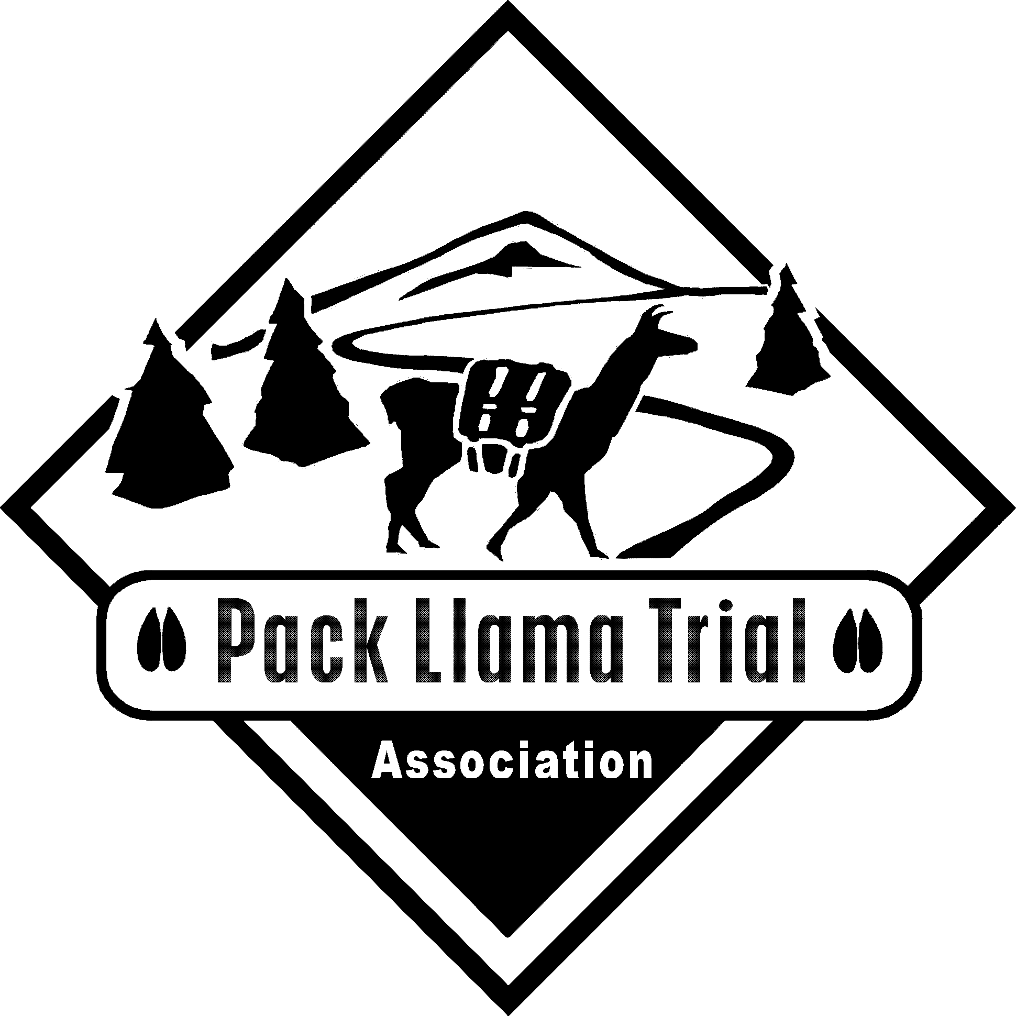
PACK LLAMA TRIAL ASSOCIATION, INC.

Dedicated to Preserving and Promoting the Pack Llama

Acknowledgement of Risk and Waiver of Liability

I, _____________________________ ____________________________________
(Participant) (Parent or Legal Guardian if under the age of 18)
hereby acknowledge that I/we have been advised of and I/we are aware of the inherent
risks and potential for injury when engaged in or participating in the Pack Llama Event being
held by__________________________________________________________________

at ______________________________________________________________________

I/we understand that this activity typically involves the leading of a llama through obstacles. These obstacles include, but are not limited to, gates, jumps, brush piles, log crossings, uneven ground, and water crossings, and that the potential for injury to llama and handler exists. I/we recognize that there is an element of risk in any adventure, sport or activity associated with the outdoors and I/we accept that the assumption of these risks is my/our responsibility alone.

Furthermore, by signing this document, I/we voluntarily release, waive, indemnify and discharge the Pack Llama Trial Association, its Board of Directors, Certifiers, Agents, Volunteers and _________________________________________________________________________
(Optional - other named entities)

from any and all liability claims, demands, actions and causes of action arising out of or related to any loss, damage or injury which are in any way connected with participation in the event or activity listed above. I/we have read, understand and accept the terms and conditions stated herein and acknowledge that this agreement shall be effective and binding upon the signatory during the entire period of participation in the said activity.

_________________________________________________ date ___________________
(Participant)

_________________________________________________ date ___________________
(Parent or Legal Guardian)

Participant's Address: ________________________________________________________

City: ___________________________________________State: _________Zip: _________

Phone: __________________________Email: ____________________________________

