2006 SE Washington Backcountry Llama Rendezvous

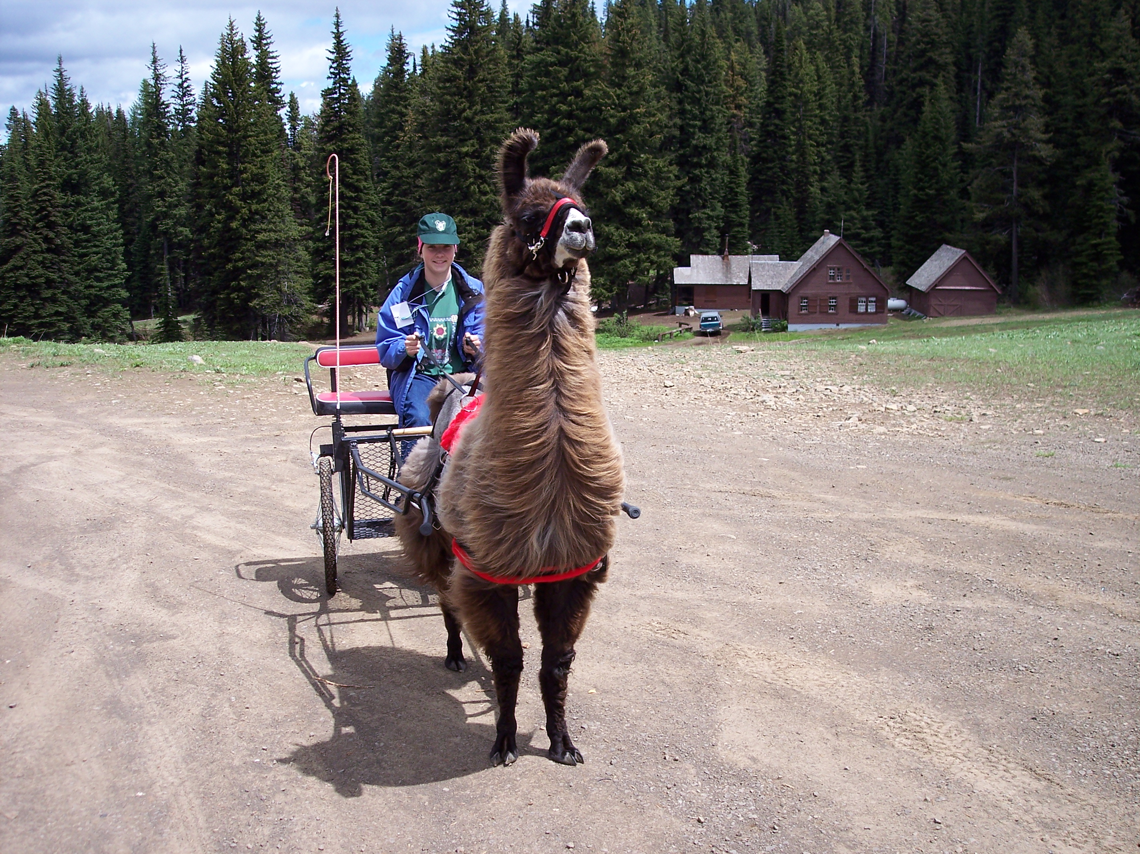
My first rendezvous was a total blast. I had so much fun! I learned how to harness a llama two different ways, both with different kinds of harnesses for carting. I also learned how to drive a cart and was actually able to drive one all by myself. I also learned a lot about packing with llamas and was able to pack with them; again, I learned how to harness them for packing. I also met a lot of wonderful people and their llamas. I met some different types of llamas that I had never seen before. It was fun talking about llamas and camping with them. Before the rendezvous, I had never camped with llamas. Everyone was so nice and I am glad I decided to go. A special thanks goes out to Anne and Merle Foss, Chippers, Jeff and Lisi Ott, and James. These wonderful people and their llamas introduced me to carting, and now I'm hooked. Thanks again for everyone who went and made my first rendezvous so much fun.

Heather Gibbons

